Digital Copy: How to talk about Doctor On Demand
This messaging guide provides content that will help your employees understand Doctor On Demand® by Included Health

Short Print Blurbs (for postcards, posters, etc.)
  - Doctor On Demand® by Included Health—get 24/7 urgent virtual care. Visit DoctorOnDemand.com/Humana
  - Did you know you can see a board-certified doctor for nonemergency care in minutes from your home, office or while traveling? With Doctor On Demand® by Included Health, it’s easy. Visit DoctorOnDemand.com/Humana
  - Introducing Doctor On Demand® by Included Health for your everyday health needs. A virtual visit usually costs less than a visit to the emergency room or urgent care. Visit DoctorOnDemand.com/Humana

Short Digital Blurbs (for intranet, team site, etc.)
  - Doctor On Demand® by Included Health is there for your everyday health needs. Learn more. [link to DoctorOnDemand.com/Humana)
  - For nonemergency healthcare, Doctor On Demand® by Included Health may cost less than a visit to the emergency room or urgent care. Learn more. [link to DoctorOnDemand.com/Humana)
  - Use Doctor On Demand® by Included Health to see U.S.-based, board-certified providers, licensed therapists or psychiatrists in minutes from your home, school or while you’re traveling within the United States. It’s easy to connect with Doctor On Demand from your smartphone, tablet or computer. Learn more. [link to DoctorOnDemand.com/Humana)
  - Doctor On Demand® by Included Health is included in your Humana healthcare plan. Your cost to see a board-certified doctor for nonemergency care is never more than $57 per visit and may be less. Register with Doctor On Demand now—it’s free to sign up. Learn more. [link to DoctorOnDemand.com/Humana)

Talking Points (team huddles, meetings, etc.)
- Your Humana medical plan includes Doctor On Demand® by Included Health—it's free to sign up. You can see a Doctor On Demand board-certified doctor within minutes for your nonemergency urgent healthcare needs—from UTIs, migraines and flu, to rashes, stress management and more. You may save money too because Doctor On Demand virtual visits usually cost less than the emergency room or urgent care.
- Doctor On Demand® by Included Health treats many common emergency room complaints. From colds, flu and UTIs to migraines, stress and anxiety, think of Doctor On Demand as your first stop for everyday care.
- Doctor On Demand® by Included Health mental health services enable you to get support for nonemergency mental health conditions including stress, anxiety, depression and trauma. The cost for a visit will vary based on your plan. You'll know the cost of your visit when you schedule your appointment.

Email Content
Subject line: Your Humana plan includes Doctor On Demand
Here’s some important news.
Doctor On Demand® by Included Health is available to Humana medical plan members—making it more convenient to get care for your everyday health needs.
With Doctor On Demand, you can see a board-certified doctor, psychiatrist or
licensed therapist—for nonemergency care—in minutes.
Here’s how Doctor On Demand works:
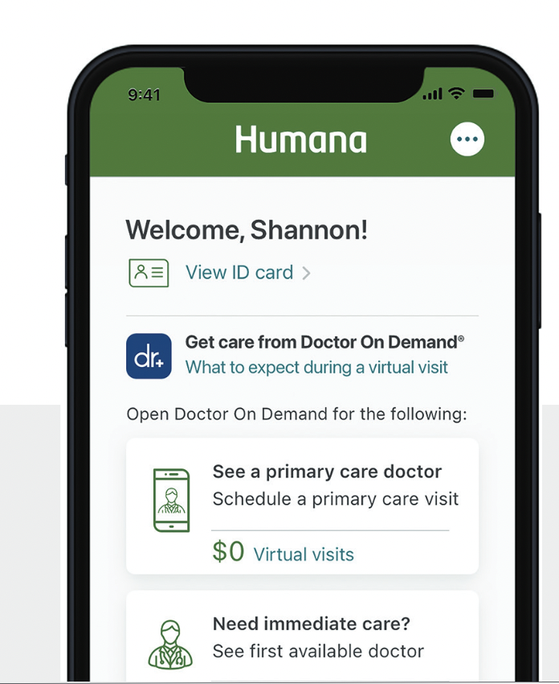
- You have access to Doctor On Demand’s urgent care and mental health providers. Select and see your favorite providers again and again, right from your smartphone, tablet or computer.

- You can see a doctor anytime, anywhere. The Doctor On Demand app makes it easy to see a doctor from your home, office or while you're traveling in the U.S.
✓ The average wait time to see an urgent care provider is usually 5 minutes or less. Mental health appointments are generally available within a few days. You choose from a variety of therapists with different backgrounds and specialties and select to see your providers again and again.

You may save money—Doctor On Demand usually costs less than
a visit to the emergency room or urgent care.
For everyday health concerns—like colds, upper respiratory infections, skin and eye problems and more—a Doctor On Demand visit costs $57 or less. For mental health services, the cost is the same as an in-office mental health visit.
Register with Doctor On Demand now!
I hope you’ll take the first step in getting quality care that's virtually there for you 24/7 by registering for Doctor On Demand today!
Sincerely,
[your name]
[your title]

Doctor On Demand is not available in Puerto Rico or outside the United States.
Limitations on telehealth services, also referred to as virtual visits or telemedicine, vary by state. These services are not a substitute for emergency care. Any descriptions of when to use telehealth services are for informational purposes only and should not be construed as medical advice. Please refer to your evidence of coverage for additional details on what your plan may cover or other rules that may apply.
This communication provides a general description of certain identified insurance or non-insurance benefits provided under one or more of our health benefit plans. Our health benefit plans have exclusions and limitations and terms under which the coverage may be continued in force or discontinued. For costs and complete details of the coverage, refer to the plan document or call or write your Humana insurance agent or the company. In the event of any disagreement between this communication and the plan document, the plan document will control.

GCHLUJTEN 923

